**1. INTRODUCTION:**

* 1. **. PURPOSE:**

**1.1.1 PSYCHOLOGY OF HUMANS IN THE CONTEXT OF NEWDAY TECHNOLOGY:**

People have long made procedures and strategies to make and safeguard their lives simpler and more secure, whether for unremarkable purposes like driving to work or more outlandish ones like flying. Portability modes advanced in lockstep with innovation enhancements, and our dependence on them rose decisively. It greatly has an impact our regular day to day existence. We can now go to places at speeds that our progenitors would never have imagined. Consistently, nearly everybody in the advanced world purposes a transportation of some sort. Certain individuals can manage the cost of vehicles, while others should depend on open transportation. People who drive, paying little heed to societal position, are dependent upon specific standards and standards of lead. One of them is remaining ready and dynamic while driving.

Dismissing our obligations towards more secure travel has empowered many great misfortunes to get related with this awesome creation consistently. It might appear as though something trifling to most people however keeping guidelines furthermore, guidelines out and about is of most extreme significance. While on street, an vehicle employs the most power and in unreliable hands, it very well may be damaging and in some cases, that thoughtlessness can hurt lives even of the individuals out and about. One sort of lack of regard isn't conceding when we are too worn out to even think about driving. To screen and forestall a damaging result from such carelessness, numerous analysts have composed research papers on driver sluggishness location frameworks. Yet, now and again, a portion of the focuses and perceptions made by the framework are not adequately exact.

Consequently, to give information and one more point of view on the main pressing issue, to work on their executions and to additionally advance the arrangement, this venture has been finished.

**1.1.2 FACTS & STATISTICS**

Our ongoing measurements uncover that simply in 2015 in India alone, 148,707 individuals kicked the bucket because of vehicle related mishaps. Of these, somewhere around 21% were caused because of exhaustion making drivers commit errors. This can be a moderately more modest even number, as among the different causes that can lead to a mishap, the contribution of exhaustion as a reason is by and large terribly underrated. Weakness joined with terrible foundation in emerging nations like India is a catastrophe waiting to happen. Exhaustion, as a general rule, is undeniably challenging to quantify or notice dissimilar to liquor and medications, which have clear key markers and tests that are accessible without any problem. Presumably, the best answers for this issue are mindfulness about exhaustion related mishaps and elevating drivers to concede exhaustion when required. The previous is hard and substantially more costly to accomplish, and the last option isn't conceivable without the previous as driving for extended periods of time is extremely rewarding.

At the point when there is an expanded requirement for a task, the wages related with it builds prompting an ever-increasing number of individuals taking on it. Such is the situation for driving vehicle vehicles around evening time. Cash propels drivers to make imprudent choices like driving the entire night even with weakness. This is predominantly since the drivers are not themselves mindful of the immense gamble related with driving when exhausted. A few nations have forced limitations on the quantity of hours a driver can drive at a stretch, yet it is as yet not enough to tackle this issue as its execution is undeniably challenging and expensive.

* 1. **SCOPE:**

There are various things out there that give the extent of exhaustion level in the drivers which are done in various vehicles. The driver sleepiness recognizable proof system outfits the similar handiness yet with further developed results and additional benefits. Similarly, it alerts the client on coming to a certain drenching point of the sleepiness measure.

* 1. **PROBLEM STATEMENT:**

Weariness is a security issue that has not yet been profoundly handled by any country on the planet fundamentally in light of its temperament. Weakness, as a general rule, is extremely challenging to quantify or notice dissimilar to liquor and medications, which have clear key pointers and tests that are accessible without any problem. Most likely, awesome answers for this issue are mindfulness about weakness related mishaps furthermore, elevating drivers to concede weakness when required. The previous is hard furthermore, significantly more costly to accomplish, and the last option is preposterous without the previous as driving for extended periods is exceptionally rewarding.

# **2.LITERATURE SURVEY:**

* 1. **DROWSINESS AND FATIGUE:**

Antoine Picot et al, expressed that sleepiness is where an individual is in conscious and sluggish state. This exact situation drives the driver to not concentrating on their driving. In this way, the vehicle can presently not be controlled because of the driver being in a semi-cognizant state.As indicated by Gianluca Borghini et al, mental weakness is an element of sluggishness and it caused the individual who encounters to not have the option to perform in light of the fact that it diminishes the productivity of the mind to answer towards unexpected occasions.

* 1. **TECNOLOGIES USED:**

**a. PYTHON**

**-** Python is deciphered, undeniable level, broadly helpful programming language. Its language development and object-situated approach mean to assist software engineers with composing clear, sensible code for little and enormous scope projects. Python is powerfully composed AND upholds numerous programming ideal models, counting procedural, object-arranged, and utilitarian programming.

**b. DIGITAL IMAGE PROCESSING**

**-** The term computerized picture handling by and large alludes to handling of a two-dimensional picture by an advanced PC. In a more extensive setting, it suggests computerized handling of any two-layered information. A computerized picture is a variety of genuine numbers addressed by a limited number of pieces. The standard benefit of Digital Image Handling techniques is its adaptability, repeatability and the safeguarding of unique information accuracy.

**i.Pixel:** A pixel is considered to be smallest unit of measurement in an image. Each pixel represents a single value. The value of a pixel in an 8-bit greyscale image ranges from 0 and 255.The intensity of light photons reaching a pixel at any position corresponds to the pixel's values. Each pixel holds a value proportionate to the power of light at that specific spot**.**

**ii. Digital Image**: A digital image is merely a collection of data numbers that depict variations in red, green, and blue at particular points on a grid of pixels**.**

**iii. Gray level:** The intensity of the image at any place is given by the magnitude of the pixel at that location, which is also known as grey level. Grayscale = (Red + Green + Blue /3) is the equation that was previously used to convert an image to grey scale. However, because red has a longer wavelength, we use the following formula:   
  
Grayscale = (0.3 * R) + (0.59 * G) + (0.11 * B)**.**

**c. MACHINE LEARNING –** Machine Learning is the logical investigation of calculations and factual models that PC frameworks use in request to play out a particular undertaking really without utilizing unequivocal guidelines, depending on examples and surmising all things considered. It is seen as a subset of electronic thinking. Machine Learning calculations assemble a numerical model in view of test information, known as "preparing information", to pursue forecasts or choices without being unequivocally told.

### **EXISTING SYSTEM:**

### **Various types of methodologies that have been developed to find out drowsiness:**

### **Physiological level approach:**

### This method involves the use of electrodes to acquire information on pulse rate, heart rate, and brain activity. ECG is used to calculate heart rate fluctuations and detect various sleepiness states. Different data such as ecg (electrocardiogram), EEG (electroencephalogram), and EMG (electromyogram) are correlated, and an output is generated to determine whether or not the person is drowsy.

### **Behavioural based approach:**

### A person's eye blinking frequency, head position, and other body movements are tracked by a camera in this technique, and the person is informed if any of these sleepiness indications are observed.

Gadgets that distinguish the respiratory rate, pulse, circulatory strain, and different boundaries are utilized in current sluggishness identification frameworks. These gadgets can cause the driver to feel uncomfortable while driving. It is difficult to know whether the drivers utilize these gadgets all of the time while driving. May become lost or breakdown, bringing about low precision in the outcome. In low-light circumstances, the ongoing innovation neglects to convey. At the point when the light is faint or low, it is hard to recognize the driver's face and eyes, bringing about more unfortunate exactness.

* + 1. **LIMITATIONS OF EXISTING SYSTEM:**
* Time taking process
* Requires a lot of external hardware
* Eye blinking is also considered as drowsiness in some systems.
  1. **PROPOSED SYSTEM:**

In proposed framework we simply assess tiredness in view of left eye and right eye utilizing just a single camera. We just consider the end of eye for longer periods just as exhaustion. As a matter of some importance the framework catches pictures through the webcam and in the wake of catching it distinguishes the face through haar cascade classifier. It utilizes haar highlights which can distinguish the face. On the off chance that the framework establishes it as face the it will continue for next stage i.e., eye location. The eye is identified similarly using haar cascade classifier and it is utilized for flicker recurrence. We are taking the help of CNN classifier for anticipating the eye status. If the two eyes are shut past edge, then a caution will be initiated to alarm the driver.

**3. SYSTEM REQUIREMENTS:**

**3.1 SOFTWARE REQUIREMENTS:**

1.PYTHON:

-Python is presently the most extensively used high-level programming language for numerous of purposes. Both the Object-Oriented and Procedural programming paradigms are supported by Python. Python programmes are typically are of less size than programmes written in other programming languages, such as Java. Programmers only have to enter a few words, and the indentation requirement of the language assures that their code is always understandable. Python is accessed by almost every internet sensation, including Google, Amazon, Facebook, Instagram, Dropbox, Uber, and many others.

Python's greatest strength is its large library of standard libraries, which can be used for the following:

* GUI Applications
* Machine Learning (like Kivy, Tkinter, PyQt etc.)
* Django is a web framework (used by YouTube, Instagram, Dropbox)
* Image manipulation (like OpenCV, Pillow)
* Scraping from the internet (like Scrapy, Beautiful Soup, Selenium)
* Multimedia
* Test frameworks

2.LIBRARIES:

**a. OpenCV:**

- OpenCV is the large open-source library for the Personal Computer vision, AI, and picture handling and presently it assumes a significant part progressively activity which is vital in the present frameworks. By using it, one can manage pictures and accounts to perceive things, faces, or regardless, handwriting of a human. It is integrated with various libraries, for instance, NumPy, python is prepared for taking care of the OpenCV display structure for assessment. To Identify picture design and its different highlights we use vector space and perform numerical procedure on these elements.

**Why OpenCV?**

**Specific**

**-**OpenCV was designed specifically for image processing. Each function and data structure has been designed with specific purposes for usage in an Image Processing application. Matlab, on the other hand, is an exceptionally nonexclusive programming language.

Toolboxes can be utilized to get nearly anything in the world.. Specific DNA toolboxes or financial toolboxes could be involved**.**

**Speedy**

**-**Matlab runs at an inexcusably slow speed. Java was used to construct Matlab. C was also used to create Java. Our computer is occupied with parsing and compiling all of the advanced Matlab code when we run a Matlab programme. Thereafter, the code is translated to Java and executed.

When we use C/C++, we don't squander as much time. The PC gets and executes machine language code directly from people. As a result, rather than more translating, we end up with more picture processing.

Subsequent to doing some ongoing picture handling with Matlab and OpenCV, we typically came by extremely sluggish outcomes, with a limit of around 4-5 casings handled each second with Matlab. With OpenCV, nonetheless, we can accomplish continuous handling in under a moment.

Sure, we pay a price for speed: we have to deal with a more cryptic language, but it's well worth it. We can do a lot more with C, such as conduct some quite complicated maths on photos while still maintaining acceptable performance for your application.

**b. TensorFlow:**

- TensorFlow is a machine learning and AI software library that is free and open-source. It can be used for a variety of applications, but it focuses on deep neural network training and inference. Deep neural networks for handwritten digit classification, image recognition, word embeddings, recurrent neural networks, sequence-to-sequence models for machine translation, natural language processing, and PDE (partial differential equation) based simulations can all be trained and run using TensorFlow. Best of all, TensorFlow allows for large-scale production prediction using the same models that were used for training.

**c. Keras:**

- Keras incorporates numerous executions of standard brain network building blocks like layers, goals, initiation capacities, enhancers, and a huge number of different devices to make working with picture and text information simpler while likewise lessening how much coding expected to compose profound brain network code. The source is kept up with on GitHub, and local area support discussions incorporate a Slack channel and a GitHub issues page.

Keras upholds convolutional and repetitive brain networks notwithstanding normal brain

networks. Other well-known utility layers upheld incorporate dropout, bunch standardization, and pooling.

. It also enables distributed deep-learning model training on clusters of graphics processing units (GPU) and tensor processing units (TPU).

**d. Pygame:**

- Pygame is a set of cross-platform Python modules for creating video games. It comes with sound and graphics libraries that may be utilised with the Python programming language.

3.OPERATING SYSTEM:

-Windows or Ubuntu.

**3.2 HARDWARE REQUIREMENTS:**

* Processor: 64-bit, quad-core, 2.5 GHz minimum per core
* RAM: 4 GB or more.
* Camera: A detachable webcam.
* HDD: 20 GB of available space or more

**4. SYSTEM DESIGN:**

**4.1 SYSTEM ARCHITECTURE:**

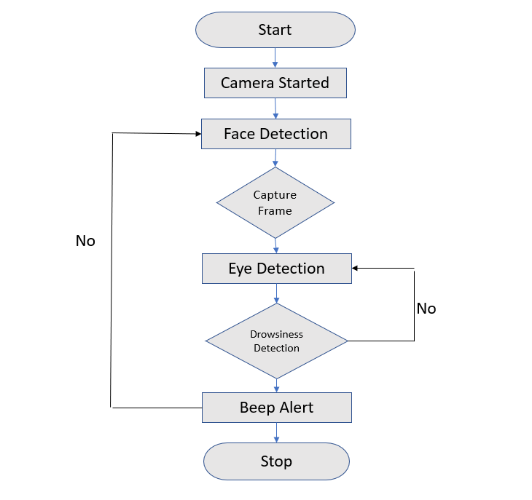

Fig no 4.1.1 Architecture

Above figure is the architecture for detecting the drowsiness of the driver. First of all the system captures images through the webcam and after capturing it detects the face through haar cascade algorithm. It uses haar features which can detect the face. If the system founds it as face the it will proceed for next phase i.e. eye detection. The eye is also detected using haar cascade features.

The entire architecture is divided into 5 steps,

**Step 1 –** Take image as input from a camera.

**Step 2 –** Identify the face in the picture and make a Region of Interest (ROI).

**Step 3 –** Identify the eyes from ROI and feed it to the classifier.

**Step 4 –** Classifier will classify whether eyes are open or shut.

**Step 5 –** Work out score to check whether the individual is sluggish.

**STEP 1:**

We will use a webcam to capture photographs as input. So, in order to access the webcam, we created an infinite loop that captures each frame. We employ the cv2 technique offered by OpenCV. To get to the camera and set the catch object, use VideoCapture(0) (cap). Each frame is read using cap.read(), and the image is saved in a frame variable.

**STEP 2:**

Face Detection:   
  
This module uses video input from the camera to attempt to detect a face. The Haar Cascade

calculation is utilized to distinguish the face. The Frontal face cascade classifier is one of the most common classifiers. A person's face is recognised in a photograph rectangular format, which was then transformed to a grayscale image. This information can be utilised to train the model.

**Haar Cascade:**

Haar Cascade depends on the idea of elements which are proposed by Paul Viola and Michael

Jones in their paper “Rapid Object Detection using a Boosted Cascade of Simple Features” in 2001.

It's a machine-learning approach in which a cascade function is learned using a large number of positive and negative photos. It can be used to detect objects from an image or a video.

This algorithm comprises of three stages:

i. Haar Feature Selection

ii. Creating Integral Images

iii. Cascading Classifiers

Though Haar Cascade is used for detecting almost all objects, it is popular for detecting faces in images. This algorithm constructs a “strong” classifier as a linear combination of weighted simple “weak” classifiers.

A Haar feature evaluates neighbouring rectangular sections in a detection window at a certain point, adds the intensities of the pixels in each region, and computes the difference between these sums. During the detection phase target-size window is dragged over the input image, and for each Haar features are calculated on a subset of the image. This distinction is then in comparison to a trained threshold that distinguishes between non-objects and objects Because Each Haar feature is only a "weak classifier," meaning that it has a low detection quality.

It is better than guessing at random, and a high number of Haar characteristics are required. They are able to accurately describe an object and, as a result, they are to construct a strong classifier, the data is grouped into cascade classifiers.

Haar-like elements are picture includes that are utilized in object acknowledgment. They were used in the first real-time face detector and got their name from their intuitive similarity to Haar wavelets. A Haar-like component thinks about contiguous rectangular locales in a discovery window at a particular area, aggregates the pixel forces in every locale, and figures the distinction between these aggregates. This distinction is then used to classify image subsections. For example, when looking at a human face, it is common to notice that the region of eyes is much dark than the region of the cheeks.

As shown in Fig. XXXXXXXXXXX,

A typical Haar include for face recognition is a couple of two contiguous square shapes over the eye furthermore, the cheek district. These square shapes' positions are characterized corresponding to a recognition window, which fills in as a bouncing box for the objective item.

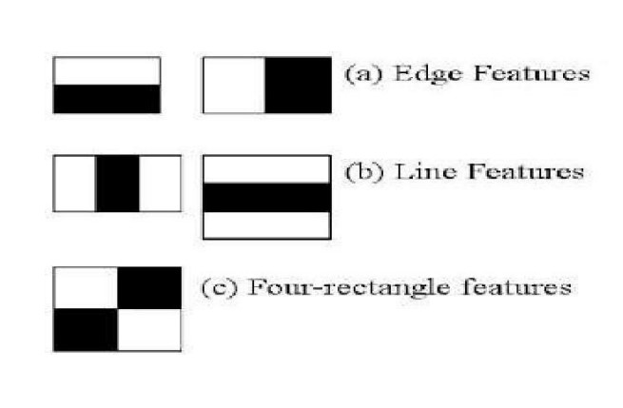

Fig no 4.1.2 Different types in Feature Extraction.

During the recognition period of the viola jones object location structure, a window of the

target size is moved over the information picture, and the Haar-like component is determined for each subsection of the picture. This difference is then compared to a previously learned threshold that distinguishes between non-objects and objects. Since such a Haar-like component is just an unfortunate student or classifier, an enormous number of Haar-like elements are expected to precisely depict an object. The Haar-like features are thus organised in a classifier cascade in the Viola–Jones object detection framework to form a strong learner classifier.

A Haar-like component enjoys a huge upper hand over most different elements concerning estimation speed. Because of the utilization of fundamental pictures a Haar-like element of any size can be determined in steady time.

An information construction and calculation for producing the amount of values in a rectangular subset of a matrix are known as necessary pictures. The undertaking is to lessen the quantity of calculations expected to figure the amounts of pixel forces inside a window

The idea is to convert an input image into a summed-area table, with the value at any point (x, y) in that table equal to the sum of all pixels above and to the left of (x, y), inclusive:

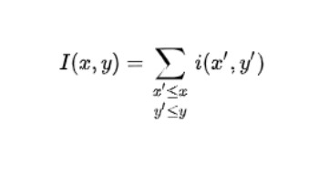

Where I(x,y) is the worth of the necessary picture pixel in the position (x,y), while i(x,y) is the

relating force in the first picture. It is a recursive equation, thus, on the off chance that we start from one corner of the info picture, we will have a similar outcome in the necessary picture.  
  
  
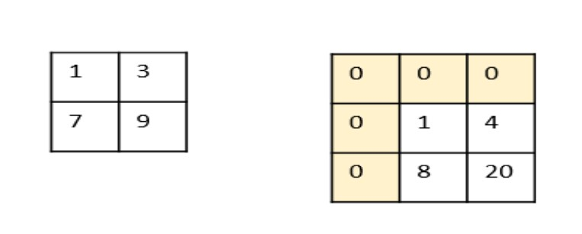

Fig no 4.1.3 Calculation of Integral image from Actual image.

We add one line and segment of zeros since we really want to return one stage to start the recursive recipe. Accordingly, assuming the first picture is w pixels wide and h pixels high, the necessary of this picture is w+1 pixels wide and h+1 pixels high.

To begin the computations, consider the first pixel in the original image from fig. XXXXXXXXXX with intensity 1: the integral image returns the same value because it computes (1+0+0). Because 3+1+0+0 equals 4, pixel '3' becomes '4'.

Utilizing similar technique, we get a '8' (7+1+0) and a '20' (9+3+1+7). Presently, we have another picture. This picture is valuable in an exceptional property of the necessary picture. Without a doubt, it worked out that if you want to register the summation inside a window in the info picture, thus that summation is equivalent to a straight blend of the comparing window's corner in the essential picture, as follows:

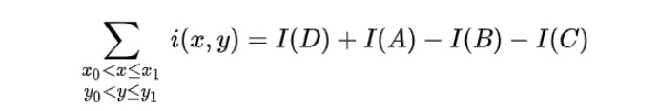

Where A, B, C and D are the sides of the relating window in the fundamental picture of fig.

DOWN

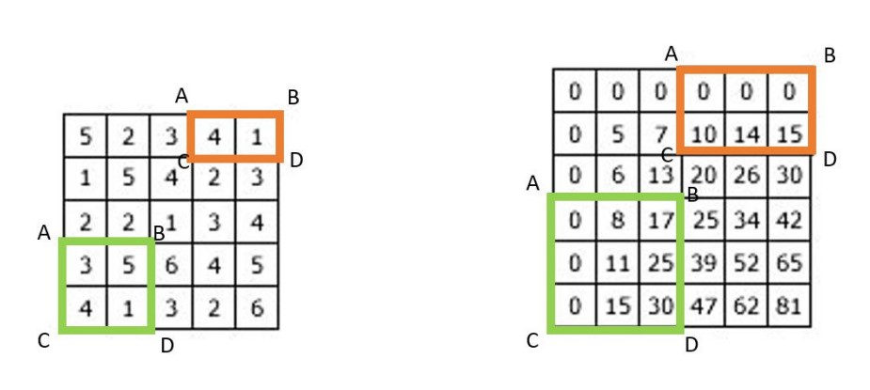

Fig no 4.1.4 Converting a 5x5 image to a 6x6 integral image.

**STEP 3:**

Eye Detection:

Because the model is working on developing a drowsiness detection system, we must concentrate on the eyes in order to identify drowsiness. The eyeballs are recognised using video input and a haar classifier called *Haar Cascade Eye Classifier* is used. Rectangular format is used to detect the eyeballs.

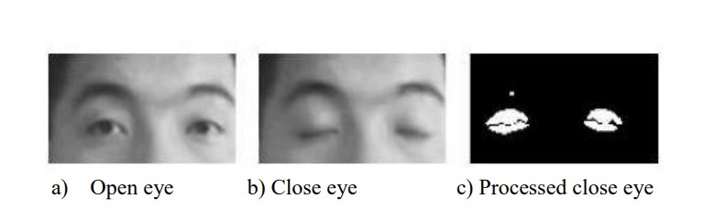

Fig no 4.1.5 Types of Eyes detected.

For eyes detection, there are four types of eyelid movement that can be used for drowsiness

detection. They are completely open, complete close, and in the middle where the eyes are from

open to close and vice versa.

The algorithm processes the images captured in grey-scale method; where the colour from the

images are then transformed into black and white. Working with black and white images is

easier because only two parameters have to be measured.

**VIOLA-JONES DETECTION ALGORITHM:**

The object detection framework Voila-Jones can be used to detect a variety of object classes, but it is more focused on the detection of face and facial features. This algorithm uses the concept of rectangle features which involves the sums of pixels within the rectangular areas. From Figure XXXXXX, the sums of the pixels that lie within the white rectangles are subtracted from the sum of pixels in the grey rectangles. The value of a two-rectangle feature, which are represented by A and B is the difference in the total of pixels between two rectangular sections. The sections have the same size and shape. They are also horizontally or vertically oriented and adjacent to each other. A three-rectangle feature, which is represented as C, computes the sum within two outside rectangles subtracted from the sum in a center rectangle. Finally, a four-rectangle feature, which is represented as D computes the difference between diagonal pairs of rectangles.

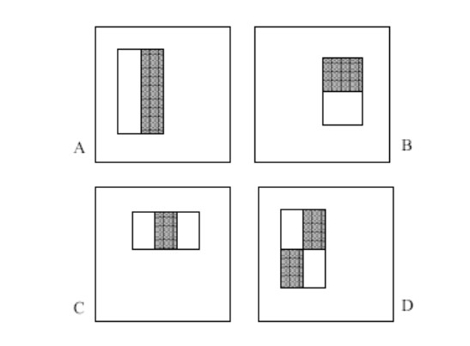

Fig no 4.1.6 Features used in Voila-Jones.

Rectangle features can be computed quickly using an image representation known as integral image.

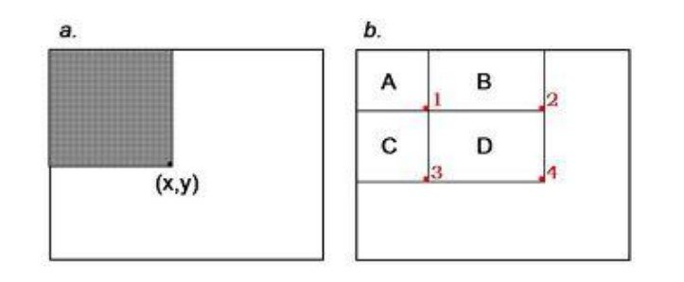

Fig no 4.1.7 Integral Image..

The worth of the vital picture at point (x, y) is the amount of the multitude of pixels above and to one side. In light of the vital picture, the amount of the pixels inside square shape D can be processed with four cluster references. The worth of the vital picture at area 1 is the amount of the pixels in square shape A. The worth at area 2 is A + B, at area 3 is A + C, and at area 4 is A + B+ C + D.

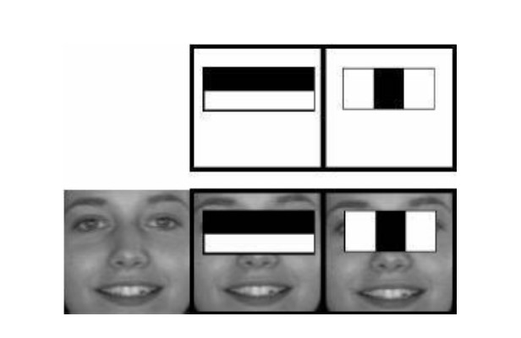

Fig no 4.1.8 Extracting using different features

The fig 3.5 is the cascade classifiers for the eyes region. In second picture eyes region is in black colour or both the eyes will have white colours. If the system founds the same pixel intensity at both the places then it detects them as the eyes. The detection is based on the intensity of the pixels around a particular object. The eyes region is white in colour and the region around the eye is black in colour. If there are white pixels found then it detects the region aseye.  
  
  
Selecting the most relevant features is performed through Adaboost technique which selects the best features and trains the classifiers that use them. This algorithm uses “Haar Cascade Frontal Face” classifier for detecting the faces since we need to detect only the frontal part of the face.

**STEP 4:**

**Convolution Neural Networks (CNN):**

The convolutional Neural Network CNN works by getting a picture, giving out it some weightage thinking about the various objects of the picture, and sometime later segregating them from one another. CNN requires very little pre-process information when wandered from other huge learning assessments. One of the urgent limits of CNN is that it applies mess methods for setting up its classifiers, which makes it sufficient to become familiar with the attributes of the objective article.

CNN depends on closely resembling design, as tracked down in the neurons of the human cerebrum, explicitly the Visual Cortex. Every one of the neurons gives a reaction to a specific boost in a particular locale of the visual region distinguished as the Receptive field. These assortments cross-over to contain the entire visual region.

CNN calculation depends on different modules that are organized in a particular work process that are recorded as follows:

* Input Image
* Convolution Layer (Kernel)
* Pooling Layer
* Characterization — Fully Connected Layer
* Structures

**CNN's Basic Architecture:**

A CNN design comprises of two key parts:

* A convolution device that isolates and recognizes the unmistakable highlights of a picture for examination in a cycle known as Feature Extraction.
* A completely associated layer that takes the result of the convolution cycle and predicts the picture's class in view of the highlights recovered before.

The CNN is comprised of three kinds of layers: convolutional layers, pooling layers, and fully connected (FC) layers.

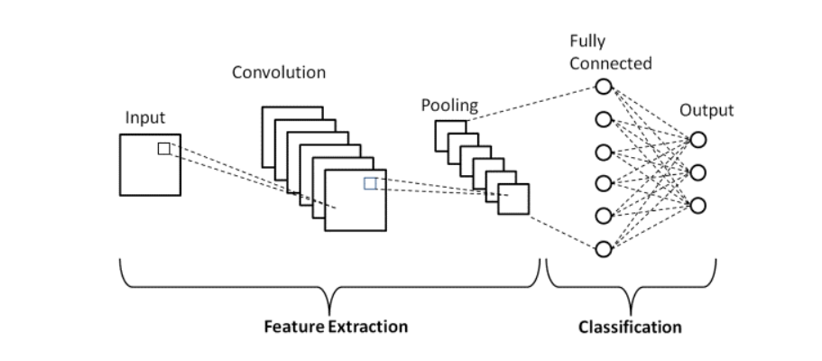

Fig no 4.1.9 Layers of CNN.

## **Convolution Layers:**

This is the absolute first layer in the CNN that is liable for the extraction of the various elements from the information pictures. The convolution numerical activity is finished between the info picture and a channel of a particular size MxM in this layer.

#### **Pooling layer:**

The Pooling layer is liable for the decrease of the size(spatial) of the Convolved Feature. This lessening in the registering power is being expected to handle the information by a critical decrease in the aspects.

There are two sorts of pooling:

1. average pooling
2. max pooling.

A Pooling Layer is normally applied after a Convolutional Layer. This layer's significant objective is to bring down the size of the convolved highlight guide to lessen computational costs. This is achieved by lessening the associations among layers and working freely on each component map. There are various kinds of Pooling tasks, contingent upon the component used.

#### **The Fully Connected:**

The Fully Connected (FC) layer involves the loads and inclinations along with the neurons and is utilized to interface the neurons between two separate layers. The last a few layers of a CNN Architecture are normally situated before the result layer.

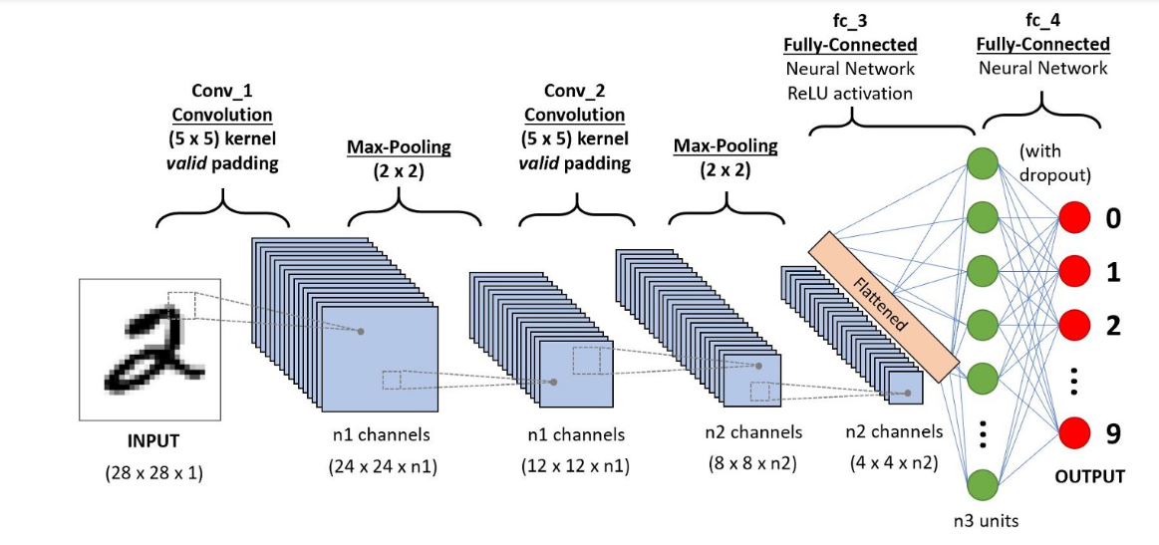

Fig no 4.1.10 Working of CNN.

The biggest component is gotten from the element map in Max Pooling. The normal of the components in a predefined measured Image portion is determined utilizing Average Pooling. Aggregate Pooling ascertains the complete amount of the parts in the predefined area. The Pooling Layer is regularly used to associate the Convolutional Layer and the FC Layer.

#### **Dropout:**

To keep away from overfitting (when a model performs well on preparing information yet not on new information), a dropout layer is used, in which a couple of neurons are eliminated from the brain network during the preparation stage, bringing about a more modest model.

**Activation Functions:**

They're used to learn and estimated any type of organization variable-to-variable affiliation that is both persistent and complex.

It gives the organization non-linearity. The ReLU, Softmax, and tanH are probably the most frequently used enactment capacities.

## **Limitations:**

* CNN utilize gigantic registering power and assets for the acknowledgment of different visual examples/drifts that is a lot of difficult to accomplish by the natural eye.
* One as a rule needs seemingly forever to prepare a convolutional brain organization, particularly with a huge size of picture datasets.
* One by and large requires exceptionally particular equipment (like a GPU) to play out the preparation of the dataset

The CNN classifier is being used to forecast the ocular state. To include our picture into the model, we should initially execute specific tasks on the grounds that the model need the appropriate aspects to start with. First, we use r_eye = cv2.cvtColor(r eye, cv2.COLOR BGR2GRAY) to convert the colour picture to grayscale. The picture is then resized to 24*24 pixels because our model was trained on 24*24 pixel images using cv2.resize(r eye, (24,24)). For better convergence, we normalise our data r_eye = r_eye/255. (All values will range from 0 to 1). To feed our classifier, increase the dimensions. model=load_model('models/cnnCat2.h5') was used to load our model. Our model now predicts each eye. lpred = model.predict_classes(l_eye). If the value of lpred[0] = 1, it states that eyes are open, if value of lpred[0] = 0 then, it states that eyes are closed.

**STEP 5:**

The score is essentially a value that will be used to determine how long the individual has closed his eyes. So, if both eyes are closed, the score increases; if both eyes are open, the score decreases. We draw the result on the screen using the cv2.putText() function, which will indicate the person's current state.

A threshold is defined, for example, if the score exceeds 15, it indicates that the person's eyelids have been closed for an extended amount of time. This is when we use sound to set off alarm using sound.play().

**4.2 UML DIAGRAMS:**

Unified Modelling Language (UML) is an abbreviation that stands for "Unified Modelling Language." Simply put, UML is a contemporary approach to software modelling and documentation. In fact, it's one of the most widely used methods for modelling business processes. It is based on representations of software components in diagrammatic form. "A picture is worth a thousand words," as the old adage goes. We can better grasp potential defects or problems in software or business processes by employing visual representations.

**4.2.1 USE CASE DIAGRAM:**

* Used to collect a system's requirements.
* Used to acquire a bird's eye view of a system.
* Identify the external and internal elements that have an impact on the system.
* Demonstrate how the requirements interact with one another.

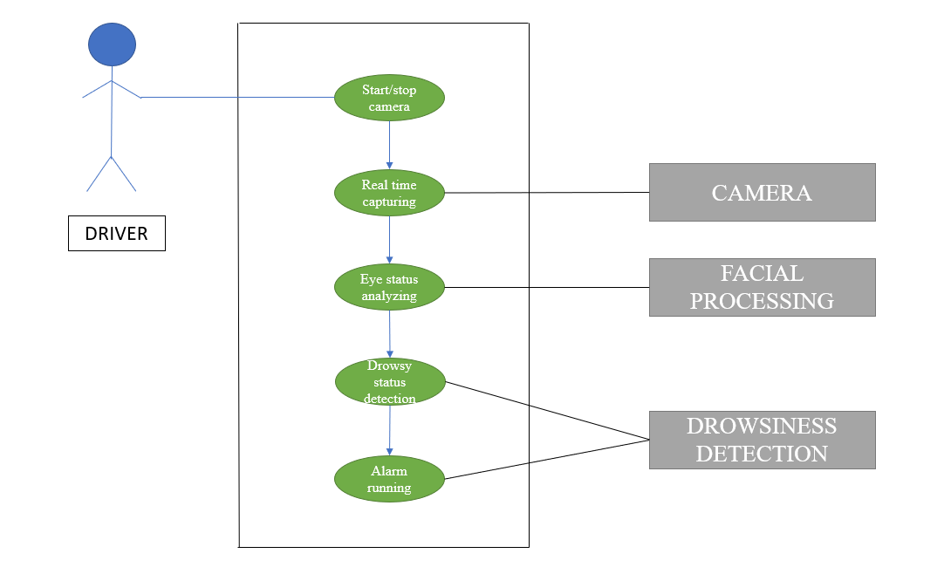

Fig no 4.2.1 Use Case Diagram.

**4.2.2 CLASS DIAGRAM:**

* Analysis and design of a static view for an application.
* Describe the responsibilities of a system.
* Shows the features and functions of each class.

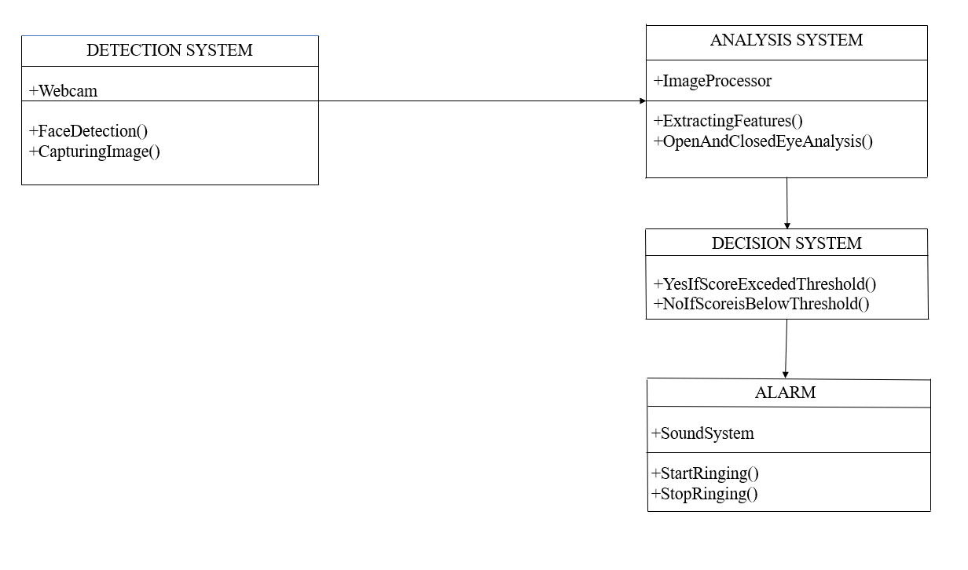Fig no 4.2.2 Class Diagram.

**4.2.3 ACTIVITY DIAGRAM:**

An activity diagram's purpose can be summarised as follows:

* Create a system's activity flow diagram.
* Describe how one activity leads to the next.

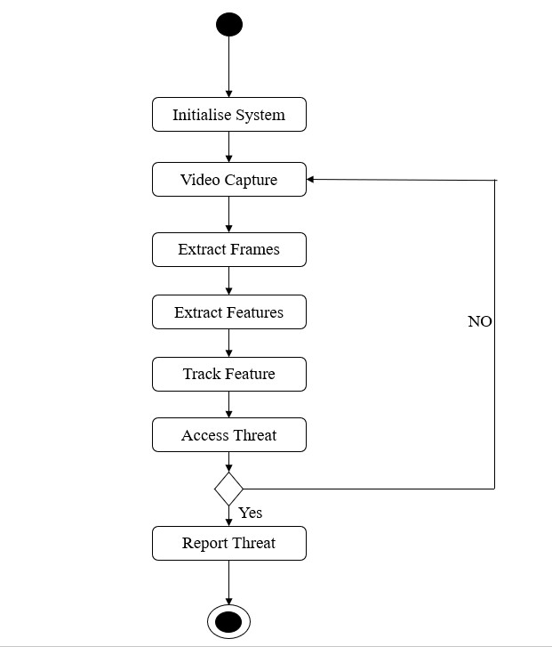

Fig no 4.2.3 Activity Diagram.

**4.2.4 SEQUENCE DIAGRAM:**

* To address the undeniable level cooperation between dynamic items in a framework.
* To simulate the interaction of items within a collaboration that is implementing a use case.
* It either simulates general interactions or specific interaction cases.

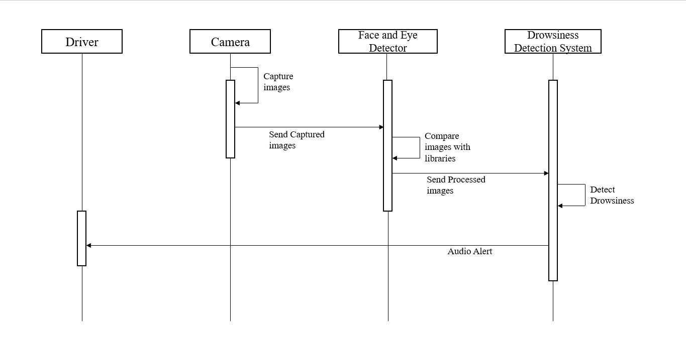

Fig no 4.2.4 Sequence Diagram.

5.SYSTEM TESTING:

The motivation behind testing is to find blunders. Testing is the cycle of attempting to find each possible shortcoming or shortcoming in a work item. It gives a method for really taking a look at the usefulness of parts, subassemblies, gatherings as well as/a completed item. It is the most common way of practicing programming with the purpose of guaranteeing that the product framework meets its necessities and client assumptions does not bomb in unsatisfactory way.

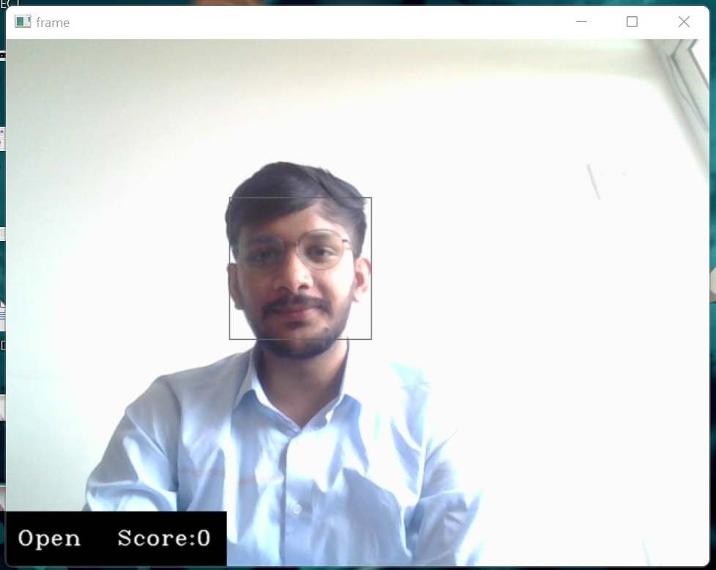

Fig no 5.1 Driver with spectacles

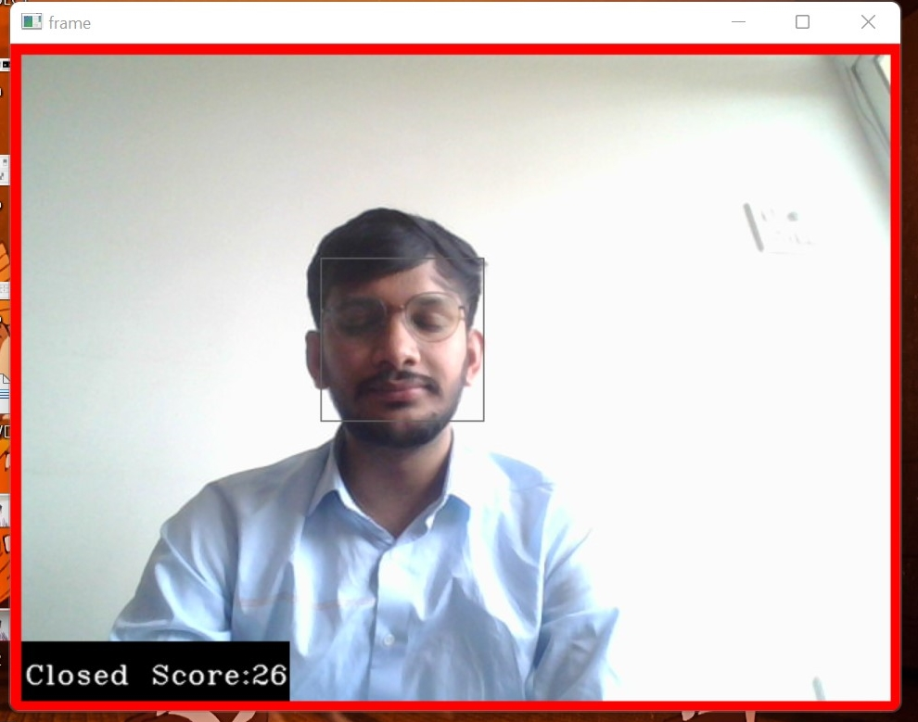

Fig no 5.2 Drowsiness Detected

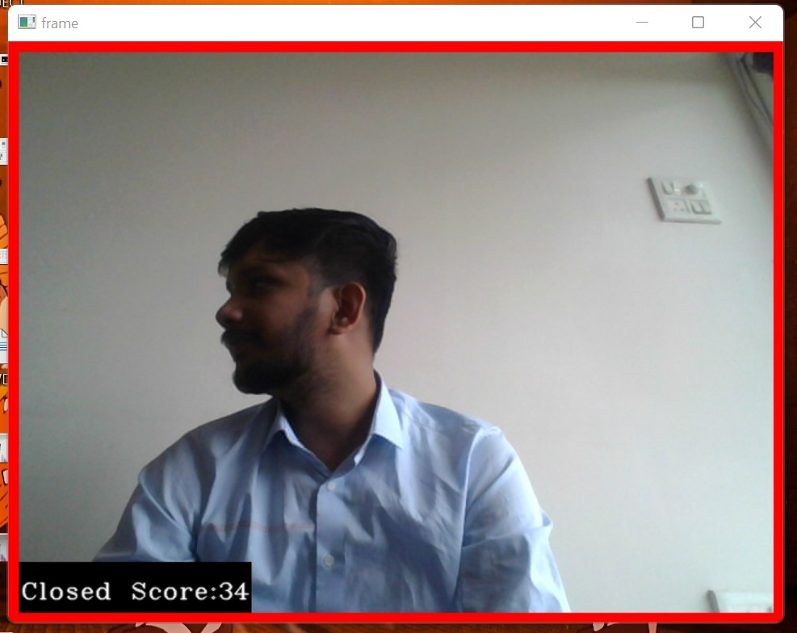

Fig no 5.3 Completely Distracted Driver

6.RESULTS:

The following steps were taken to implement sleepiness detection with Python and OpenCV: Successful video capture using camera during runtime. The captured footage was separated into frames, and each frame was evaluated separately. Face detection was successful, followed by eye detection. If an eye closes for successive frames, it is labelled as drowsy; otherwise, it is considered a normal blink, and the cycle of recording images and analysing the driver's state is repeated.

**Sample 1:**

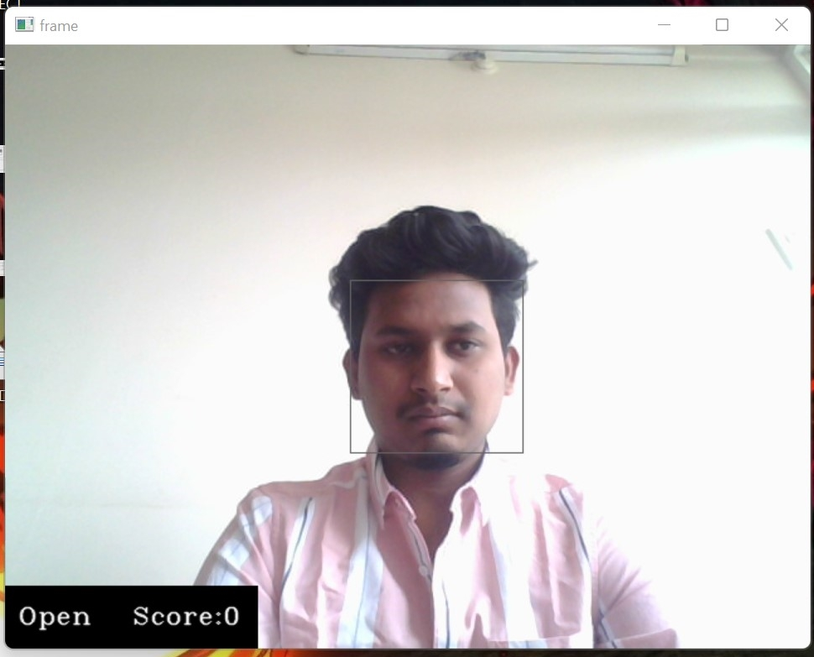



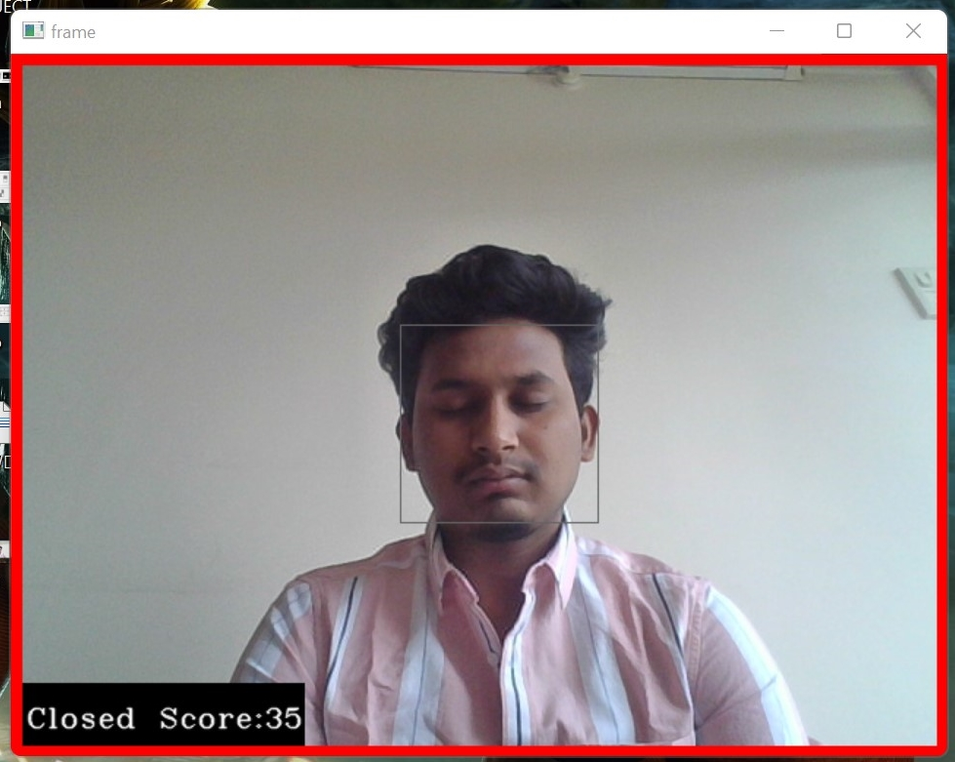

Sample 2:

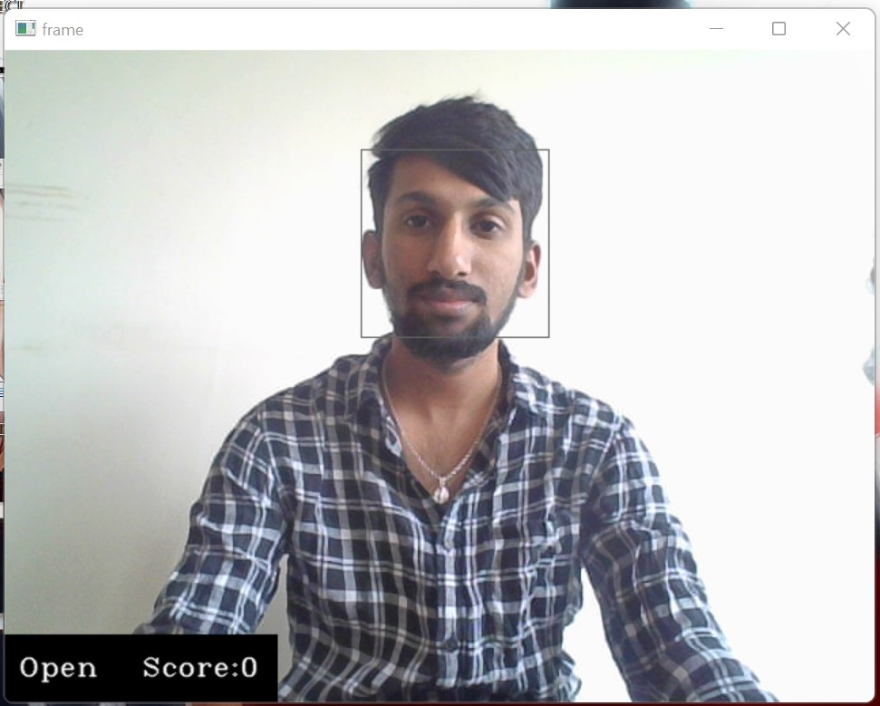

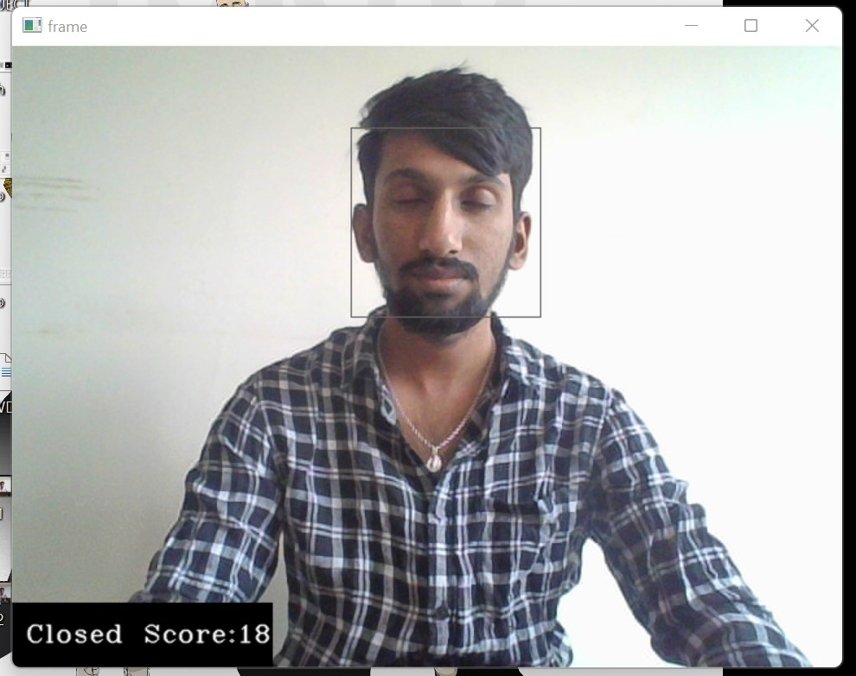

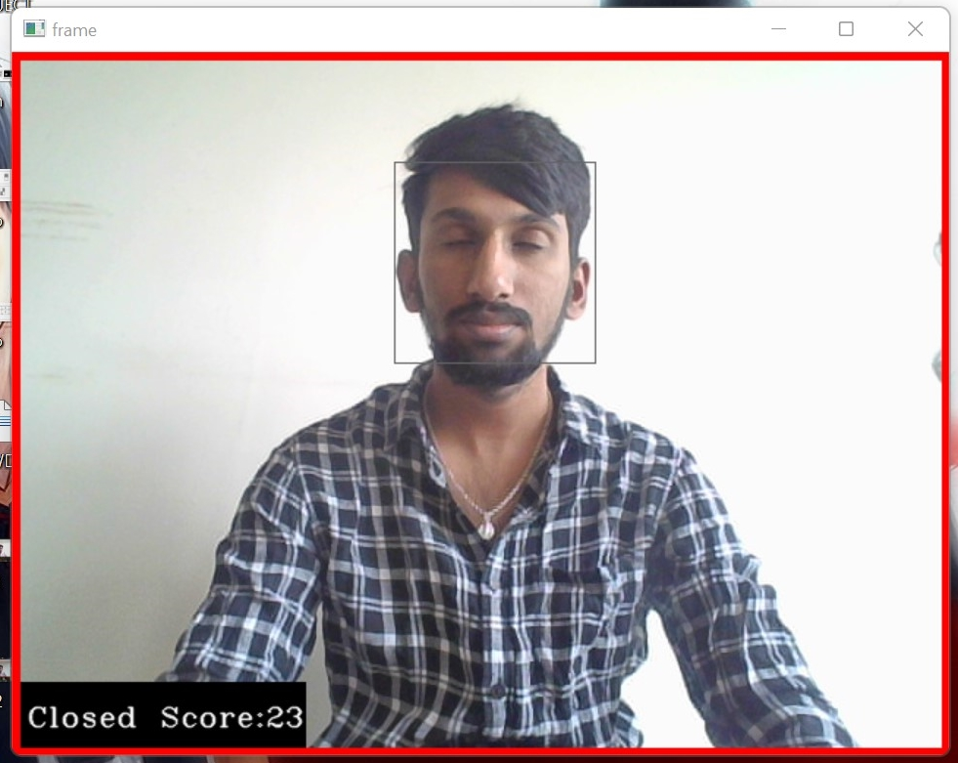

**Sample 3:**

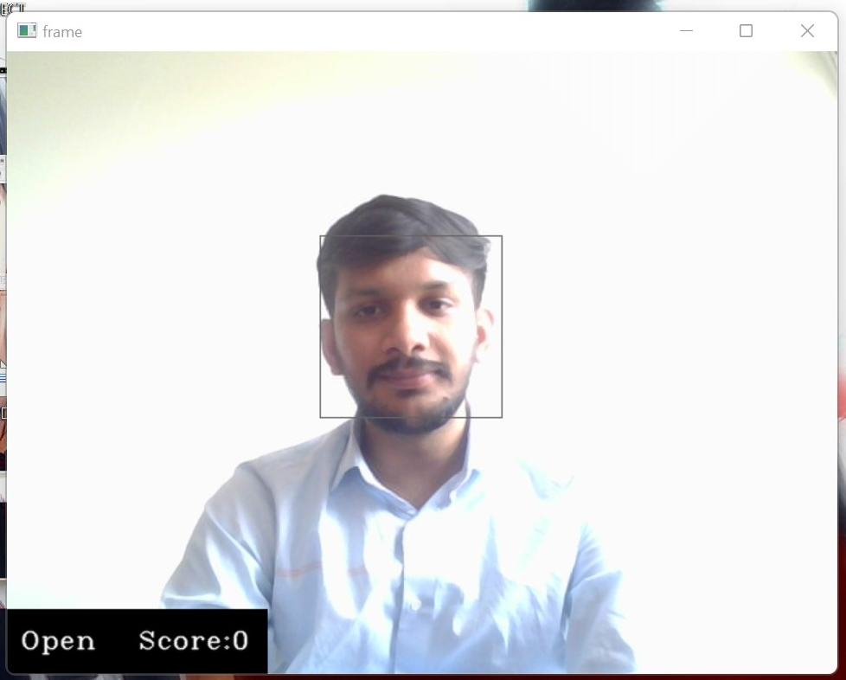

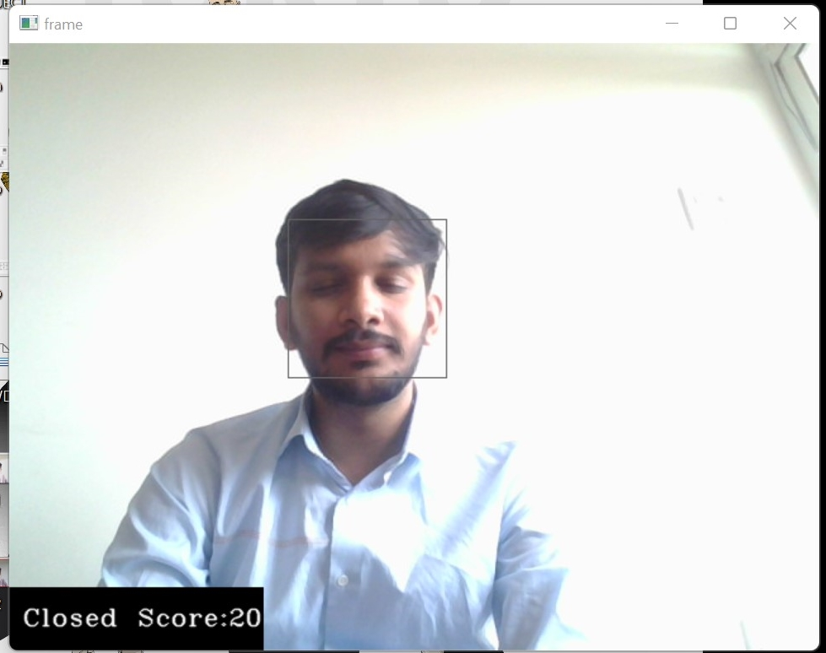

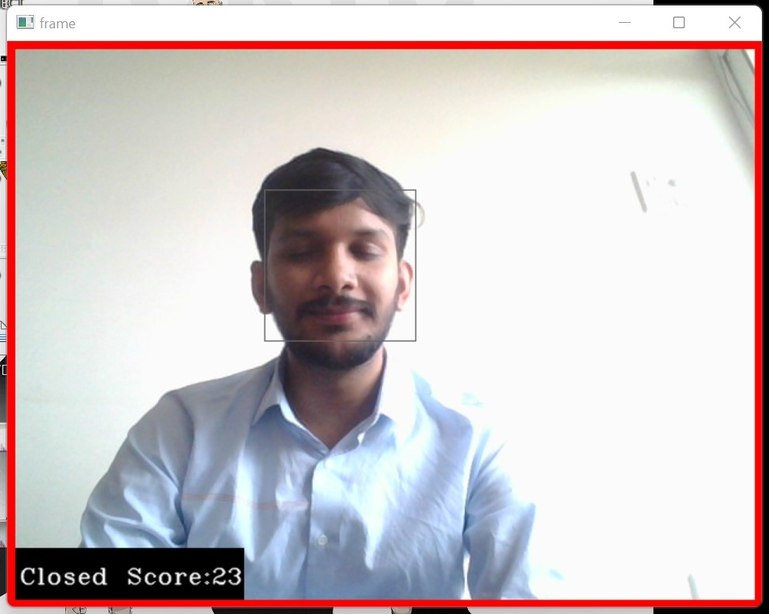

**7.CONCLUSION AND FUTURE SCOPE**

**7.1 CONCLUSION:**

It completely meets the objectives and requirements of the system. The framework has achieved an unfaltering state where all the bugs have been disposed of. The framework cognizant clients who are familiar with the framework and comprehend it's focal points and the fact that it takes care of the issue of stressing out for individuals having fatigue-related issues to inform them about the drowsiness level while driving. This system can be used to reduce the amount of road accidents that happens to great extent.This can save a lot of lives which is main motive of the system.Taking facts into consideration driver drowsiness alert system is future of road safety**.**

**7.2 FUTURE SCOPE:**

In the real-time driver fatigue detection system, it is required to slow down a vehicle automatically when the fatigue level crosses a specific limitIt is suggested that a continuous scale driver fatigue monitoring system be constructed instead of a threshold sleepiness level. It continuously monitors the level of tiredness and generates a signal that regulates the vehicle's hydraulic braking system when it surpasses a certain threshold. Hardware components are needed. Dedicated hardware for image acquisition processing and display Interface support with the hydraulic braking system which includes relay, timer, stepper motor and a linear actuator. Function When drowsiness level exceeds a certain limit then a signal is generated which is communicated to the relay through the parallel port(parallel data transfer required for faster results).The relay drives the on delay timer and this timer in turn runs the stepper motor for a definite time period .The stepper motor is connected to a linear actuator. The linear actuator converts rotational movement of stepper motor to linear motion. This linear motion is used to drive a shaft which is directly connected to the hydraulic braking system of the vehicle. When the shaft moves it applies the brake and the vehicle speed decreases. Because it reduces the vehicle speed to a manageable level, the odds of an accident occurring are considerably reduced, which is very useful for avoiding crashes caused by drowsiness.

8.REFERENCES:

[1] http://www.scribd.com/doc/15491045/Learning-OpenCV-Computer-Vision-with-the-OpenCV-Library

[2] Learning OpenCV by Gary Bradski and Adrian Kaehler

[2] Facial Features Monitoring for Real Time Drowsiness Detection by Manu B.N, 2016 12th International Conference on Innovations in Information Technology (IIT) [Pg. 78-81] <https://ieeexplore.ieee.org/document/7880030>

[4] Real Time Drowsiness Detection using Eye Blink Monitoring by Amna Rahman Department of Software Engineering Fatima Jinnah Women University 2015 National Software Engineering Conference (NSEC 2015) <https://ieeexplore.ieee.org/document/7396336>

[5] Warwick, B., Symons, N., Chen, X., & Xiong, K. (2015). Detecting Driver Drowsiness Using Wireless Wearables. 2015 IEEE 12th International Conference on Mobile Ad Hoc and Sensor Systems.

[6] Tayab Khan, M., Anwar, H., Ullah, F., Ur Rehman, A., Ullah, R., Iqbal, A., … Kwak, K. S. (2019). Smart Real-Time Video Surveillance Platform for Drowsiness Detection Based on Eyelid Closure. Wireless Communications and Mobile Computing, 2019.

[7] T. Welsh, M. Ashikhmin, and K. Mueller, "Transferring color to greyscale images," ACM Transactions on Graphics, vol. 21, pp. 277-280, 2002.

[8]http://ncrb.gov.in/StatPublications/ADSI/ADSI2015/chapter1A%20traffic%20accidents.pdf

[9] OPEN/CLOSED EYE ANALYSIS FOR DROWSINESS DETECTION; P.R. TABRIZI AND R. A. ZOROOFI.

[10] <https://en.wikipedia.org/wiki/Somnolence>

[11]<https://docs.opencv.org/3.4/db/d28/tutorial_cascade_classifier.html>

[12] RamalathaMarimuthu, A. Suresh, M. Alamelu and S.Kanagaraj “Driver fatigue detection using image processing and accident prevention”, International journal of pure and applied mathematics, vol. 116, 2017.

[13] <https://stackabuse.com/image-recognition-in-python-with-tensorflow-and-keras/>

[14] <https://becominghuman.ai/building-an-image-classifier-using-deep-learning-in-python-totally-from-a-beginners-perspective-be8dbaf22dd8>

[15] Q. Wang, J. Yang, M. Ren, and Y. Zheng, "Driver fatigue detection: a survey," in Intelligent Control and Automation, 2006. WCICA 2006. The Sixth World Congress on, 2006, pp. 8587-8591.